**Project Design Phase**

**Solution Architecture**

|  |  |
| --- | --- |
| Date | 28 June 2025 |
| Team ID | LTVIP2025TMID35088 |
| Project Name | **Enhanced Wings: Marvels of Butterfly Species** |
| Maximum Marks | 4 Marks |

**Solution Architecture:**

**🔹 Step 1: Data Collection & Preprocessing**

* Collect butterfly images and metadata (e.g., species name, location, habitat) from publicly available datasets and community contributions.
* Perform **image cleaning**, resize inputs, apply **augmentation techniques**, and encode labels.
* Prepare data for training using standard image preprocessing techniques (e.g., normalization, grayscale conversion if needed)

🔹**Step 2:Model Training**

* Train a **Convolutional Neural Network (CNN)** or pre-trained model (e.g., ResNet, MobileNet) for butterfly species classification.
* Evaluate the model using metrics like **accuracy, precision, recall**, and **F1-score**.
* Save the trained model using **TensorFlow/Keras** or **PyTorch**, along with label mappings.

**🔹 Step 3: Backend Development (Flask)**

* Build a Flask-based backend API to handle image uploads and model inference.
* The backend processes incoming images, runs the prediction, and returns the identified species, confidence score, and optionally, ecological insights**.**

**🔹 Step 4: Frontend Development**

* Develop an interactive, user-friendly web interface using HTML, CSS, JavaScript, and Bootstrap.
* Include pages such as: Home, Upload & Identify, Species Info, Map View, and About Project.
* Display prediction results clearly with species images, name, confidence, and distribution details**.**

**🔹 Step 5: Deployment & Access**

* Deploy the full application on cloud platforms like Render, Heroku, or Vercel.
* Ensure accessibility through any modern web browser, making it usable for researchers, students, and nature lovers in the field.
* Plan future scalability with support for mobile devices, offline modes, and crowdsourced data contributions**.**

**Flow chart:**

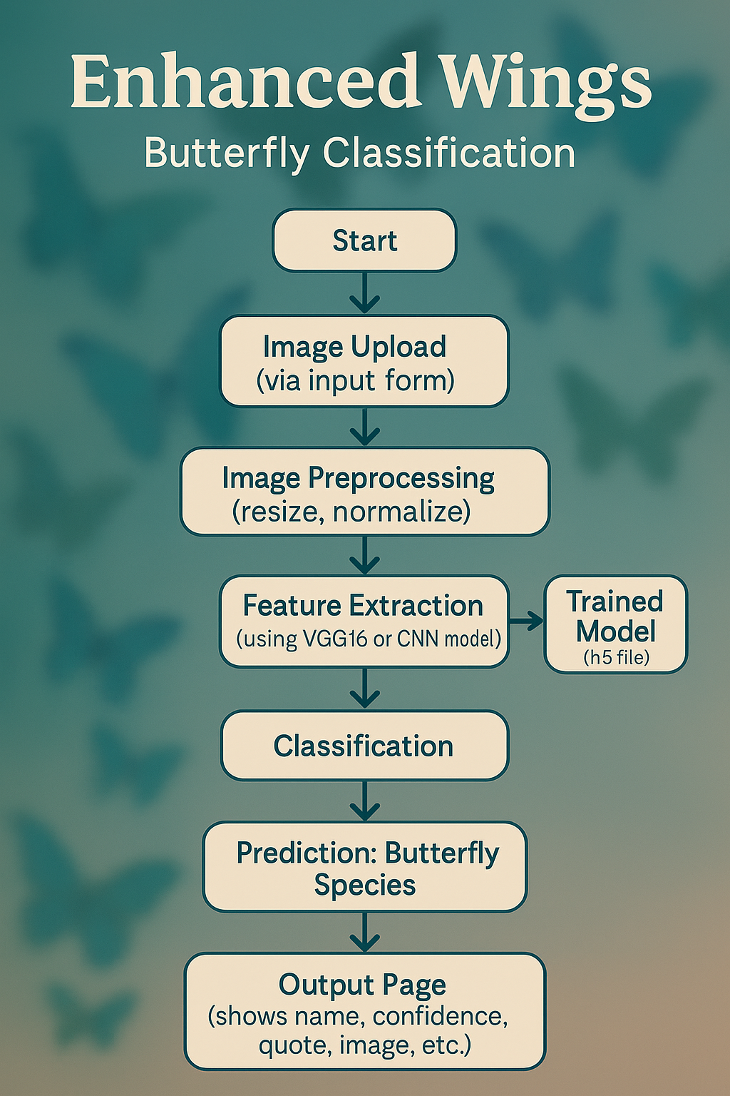

**Example – solution Architecture Diagram:**

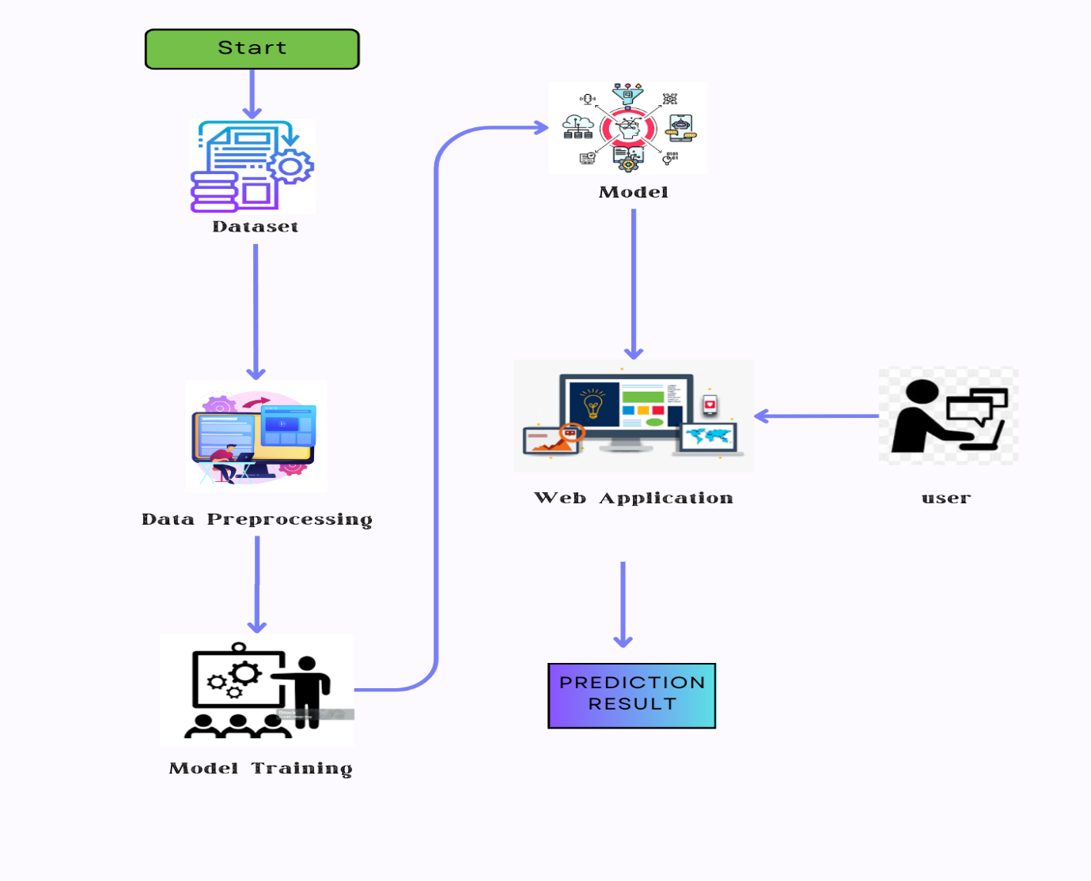

**References:**

1. **👉**[**https://www.sciencedirect.com/science/article/pii/S266730532300039X**](https://www.sciencedirect.com/science/article/pii/S266730532300039X)
2. **👉**[**https://www.mdpi.com/2079-9292/11/13/2016**](https://www.mdpi.com/2079-9292/11/13/2016)
3. 👉<https://www.kaggle.com/datasets/phucthaiv02/butterfly-image-classification>
4. 👉<https://www.researchgate.net/publication/370959457_The_Automatic_Identification_of_Butterfly_Species_Using_Deep_Learning_Methodologies>